## ABSTRACT

VR library is a new type of library based on the new technology of digital, network-based, intelligent and the new concepts of management, which has gradually become the future library model. The users interact with the virtual world in a natural way in 3D virtual environment to achieve real visual, tactile, and auditory and factory experience. We use VR technology to develop a virtual library system.VR experience virtual library scene construction, virtual roaming and scene interaction and book retrieving by connecting with the library management system. System admin will collect the ebooks of all the library books available and add those books to the VR System where students can able to access those e-books through VR headset. The pdf file is processed to generate the summary of the ebook and an audio clip of the summary. The summary is displayed first once the user clicks on the ebook in virtual environment user can listen to the audio clip of the summary and can read the book page by page.

i

#### Chapter No. Title Page No.

**Acknowlegement i**

**Abstract ii**

**List of Tables v**

**List of Figures vi**

1. **INTRODUCTION 01**
   1. Background
   2. VR headset
   3. Problem Statement
   4. Proposed Solution

#### LITERATURE SURVEY 05

* 1. Virtual Reality Technology
  2. Application of VR Technology
  3. Abstractive text summarization
  4. text summarization sequence -sequence Model

#### SYSTEM REQUIREMENT SPECIFICATION 08

* 1. Introduction

3.2 Project Scope

3.3 Aim

3.4 Operating Environment

3.5 Functional Requirements

3.6 Non-Functional Requirements

3.7 user class and characterstics

3.8 Hardware requirements

3.9 Software requirements

ii

#### PROPOSED METHODOLOGY 15

* 1. System Architecture and
  2. system design
  3. Sequence Diagram

4.4 Proposed methodology

4.4.1 add e books

4.4.2 Text Rank extraction

4.4.3 Text Summarization methods

4.4.4 Design of VR

4.4.5 Hardware Guesture

4.4.6 Select Ebooks

#### IMPLEMENTATION DETAILS 28

* 1. Software Tools
  2. Modules

#### RESULTS AND DISCUSSION 30

* 1. Web page for VR library
  2. Upload ebook page
  3. Text extraction of pdf file

6.4 text summarization of file

6.5 vr design

* 1. Summary and audio file display

#### CONCLUSION 36

**8 References 37**

iii

|  |  |  |  |  |  |  |  |  |  |  |
| --- | --- | --- | --- | --- | --- | --- | --- | --- | --- | --- |
|  | **LIST OF TABLES** | |  | |  | |  | |  | |
| **Table No.** | **Title** | | **Page No.** | |  | |  | |  | |
|  |  | |  | |  | |  | |  | |
| 3.1 | Hardware Requirements | | 14 | |  | |  | |  | |
| 3.2 | Software Requirements | | 14 | |  | |  | |  | |
| 5.1 | Software Tools | | 28 | |  | |  | |  | |
|  |  | |  | |  | |  | |  | |
|  | | | iv  **LIST OF FIGURES** | |  | |  | |  | |  | |
| **Figure No.** | | | **Title** | | **Page No.** | |  | |  | |  | |
| 1.1 | | | Smartphone HMDs from simpler | | 02 | |  | |  | |  | |
| 1.2 | | | The 2 types of positional tracking, Outside-in (a) and Inside-out (b). | | 03 | |  | |  | |  | |
| 1.3 | | | Technology Preference for security products, CyberThreat Défense Report 2020 | | 04 | |  | |  | |  | |
| 4.6 | | | Page Rank working | | 22 | |  | |  | |  | |
| 4.7 | | | Aurduino and Node Mcu Guesture | | 26 | |  | |  | |  | |
| 4.1 | | | System Architecture | | 15 | |  | |  | |  | |
| 6.1 | | | Web page for VR library | | 30 | |  | |  | |  | |
| 6.2 | | | Upload ebook page | | 31 | |  | |  | |  | |
| 6.3 | | | Text extraction of pdf file | | 32 | |  | |  | |  | |
| 6.4 | | | Text summarization of file | | 33 | |  | |  | |  | |
| 6.5 | | | vr design | | 34 | |  | |  | |  | |
| 6.6 | | | Summary and audio file display | | 35 | |  | |  | |  | |
| 4.2 | | | Data flow diagram level 0 | | 16 | |  | |  | |  | |
| 4.3 | | | Data flow diagram level 1 | | 17 | |  | |  | |  | |
| 4.4 | | | Data flow diagram level 2 | | 18 | |  | |  | |  | |
| 4.5 | | | Sequence Diagram | | 19 | |  | |  | |  | |

v

# CHAPTER-1

**INTRODUCTION**

Virtual reality (VR) is a simulated experience that can resemble or differ from the actual world. Virtual reality can be used for entertainment as well as education. Other types of VR technologies include augmented reality and mixed reality. Virtual reality headsets or multi-projected environments are currently used in typical virtual reality systems to provide realistic visuals, sounds, and other sensations that replicate a user's physical presence in a virtual environment. A person using a virtual reality kit can see the virtual world, move around in it, and interact with virtual features or objects. VR headsets with a small screen in front of the eyes are usually used to get this effect, but it can also be achieved in specially constructed rooms with several huge screens. The virtual reality library (VR library) is a new form of library that focuses on expanding digital, network-based, smart technology and new management ideas, and is swiftly becoming the library of the future. Virtual reality normally includes audio and video feedback, but haptic technology can also provide extra sensory and force feedback. The purpose of virtual reality technology is to better human-computer interaction. In a 3D virtual environment, users interact with the virtual world in a natural way to generate a genuine visual, tactile, aural, and factory experience. Using virtual reality technology, we constructed a virtual library system.

The Virtual library consists of thousands of online ebooks and is easy to use-members just need to log in to our website to obtain instant access. We have integrated text summarization with the ebook so that users can read and listen to the summary first and, if interested, can read the whole book. This feature will save time for the user. System admin will collect the e books of all the library books available and add those books to the VR System where students can be able to access those e-books through a VR headset. The pdf file is processed to generate the summary of the ebook and an audio clip of the summary. The summary is displayed first once the user clicks on the ebook in the Virtual environment and can listen to the audio clip of the summary and can read the book page by page.

**1.1 Background**

Due to our busy life schedule, we hardly get time to go to the library and read books. We may not even get access to all the books in the nearby library. And we can not go to the library all the time. Sometimes we may face problems, like after reading a book we may not find interesting and skip that book. That wastes our time. So we need a platform where we can get a chance to read or listen to the summary of the book.

**1.2 VR Headset**

The Head Mounted Display (HMD) is a stereoscopic display that projects one image in front of each eye, giving the user a sense of depth and allowing them to fully immerse themselves in the three-dimensional world. Modern HMDs have cutting-edge graphics and sensors, despite the fact that the first HMD was launched in 1968. Depending on the form of HMD, head tracking can be used to communicate with it.Using eye tracking or motion tracking, the user can switch or talk in the virtual world in real time. Smartphone HMDs-A smartphone HMD is a headset that shows details by placing a smartphone in front of the user's eyes. The user can turn or chat in the virtual world in real time using eye tracking or motion tracking.Smartphones with Head-Mounted Displays (HMDs)-A smartphone with a head-mounted display is a screen that projects information onto the user's eyes by putting a smartphone in front of them.Except for the Samsung Gear VR, which has its own internal IMU, these HMDs use the smartphone's own Inertial Measurement Unit (IMU) for rotational tracking, which consists of an accelerometer, gyroscope, and sometimes magnetometers.

**Figure 1.1 : Smartphone HMDs from simpler (a) Google cardboard (b) Day dream view and**

**(c) Samsung gear VR**

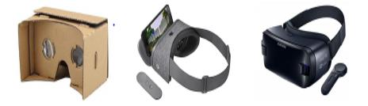

**PC HMDs-**Positional tracking is used for room orientation in PC-driven HMDs in addition to the IMUs that are used for rotational tracking. The two most common types of positional tracking are outside-in (shown in figure 1.2 (a)) and inside-out (shown in figure 1.2 (b). Platforms like the Oculus Rift and HTC Vive use outside-in tracking, as shown in Figure 1.2. (a).in situations where external trackers or beacons are needed SteamVR Lighthouses are infrared beacons that communicate with the HMD's infrared receivers and other devices such as handheld controllers. Rift relies on a third-party optical system.Infrared LED markers on the HMD and its accessories are detected by constellation sensors. Inside out monitoring usually uses time of flight sensors or stereo vision to detect and map changes in relative location. Without markers, inside-out tracking uses simultaneous localization and mapping (SLAM)While keeping track of the user's position, an algorithm produces or updates a map of an unknown area. Which is used in Windows Mixed Reality (WMR) HMDs like the Samsung Odyssey, Hp, HTC which are shown in figure 1.3.

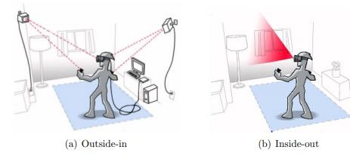

**Figure 1.2 : The 2 types of positional tracking, Outside-in (a) and Inside-out (b).**

Outside-in control has the advantage of having explicit signaling/patterns on the beacons or markers, making tracking computations simpler. The computing power required is lower since there is less data to process, and the tracking accuracy tends to be higher. On the downside, the user must remain in the tracker/line beacon's line of sight to avoid occlusion. Although inside-out tracking is simpler to set up, it requires more sophisticated vision processing and computing power. Both PC-driven HMDs are now attached to a server, restricting the options available to the user. Wireless communication between the PC and the HMD is currently being established.

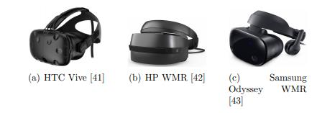

**Figure 1.3: 3 different PC driven HMDs from different manufactures (a) HTC, (b) HP and (c)**

**Samsung**

**1.2 Problem Statement**

There are a variety of problems that one has to remember when designing some kind of learning environment. These problems become even more complicated when developing a learningenvironment based on modern and largely unexplored instruments, such as virtual reality (VR). Due to our busy life schedule, we hardly get time to go to the library and read books. We may not even get access to all the books in the nearby library. And we can not go to the library all the time. Sometimes we may face problems, like after reading a book we may not find interesting and skip that book. That wastes our time. So we need a platform where we can get a chance to read or listen to the summary of the book.

**1.3 Proposed Solution**

We propose a virtual reality system in which the user will be immersed in a 3D world while moving. Reading ebooks, for example, would be done with the help of an Android smartphone. This will allow for the superimposition of actual and virtual world visuals, resulting in a whole new viewing experience. A web application has been designed for the admin, who can upload ebooks in pdf format. The pdf file is processed by the server to extract the text content from it. The complete text is processed for text summarization. Users can listen and read the summary before reading the ebook. We may feel tempted to browse the virtual library and select a book to read.

**Advantages**

* Helps with Impressive Visualization
* Creating Interest
* Improves Educational Value
* It is easy to use.

# CHAPTER-2

**Literature Survey**

**2.1 Virtual Reality Technology**

JinfengLei and Qin [1] illustrate Immersion, entertainment, intrusion, and personalization are just a few of the benefits that virtual reality has to offer. Multimedia technology is widely used in the field of advertising communication, and people's production and living lifestyles are evolving. Future development prospects of advertising communication using virtual reality technology, in order to serve as a reference for a variety of advertising-related industrial processes, such as design and communication. Virtual reality is not only a cutting-edge technology, but it also has the ability to revolutionise the advertising industry. It can turn two-dimensional advertising data into three-dimensional data and improve interactivity. Advertising materials will also continue to evolve. Virtual reality is currently widely used in a wide range of industries. It also promotes the evolution of advertising communication modes, as well as advertising content innovation, as well as advertising's influence and interest. At the same time, changing the advertising platform is the most important component of advertising communication in the modern era. Furthermore, research and analysis show that the impact of employing virtual reality technology in advertising communication is considerably superior to that of utilising a mobile phone or a computer for advertising communication. In the future, virtual reality technology's application in advertising communication will advance in terms of comprehensiveness, technology, and quality.

## **2.2** Application of VR

Kai Zhang and Sai-Jun Liu [2] illustrate For PE teachers, virtual reality technology provides a brand-new educational experience. In the typical teaching procedure, teachers can only monitor students from one perspective, and they are unable to carefully follow the quick movements, thus they are unable to provide specific instruction. Those issues, however, can all be overcome with the use of virtual reality technology, and teachers from diverse fields can share texts, photographs, videos, and other multimedia content. Using interactive and dynamic 3D visualised objects, they may have a more effective exchange of ideas. Make sports more appealing to students while lowering injury rates. The system of PE education and training with Virtual reality technology was combined by the following factors: (1) a software application system (2) a sports database system (3) devices for gathering and displaying movement data (4) a high-performance computer image processing system (5) a platform for the development of virtual reality technologies.

**2.3 Abstractive text summarization**

Panagiotis Kouris, Georgios Alexandridis, Andreas Stafylopatis [3] illustrate A combination of deep learning and semantic data transformations generated the abstractive text summarization. A theoretical model for semantic-based text generalisation is introduced and utilised in conjunction with a deep encoder-decoder architecture to provide a summary in generalised form. Following that, a methodology is suggested for converting a generalised summary into human-readable form while keeping key informational components of the original text and solving the problem of out-of-vocabulary or rare words. The overall methodology is tested on two well-known datasets, yielding promising results. This transformation is based on the notion that machine learning systems typically require a large number of training samples before making reliable predictions. As a result, low-frequency phrases should ideally be substituted by high-frequency hypernyms that communicate the original meaning semantically. The separate semantic representation of each word could help the deep learning model perform even better.

**2.4 Text Summarization with Sequence-to-Sequence Models**

Tian shi, Yaser keneshloo, Naren ramakrishnan, Chandan k. Reddy [4] illustrate Neural abstractive text summarization, sequence-to-sequence (seq2seq) models have garnered a lot of interest. Many new approaches to improving seq2seq models have been developed, allowing them to deal with issues like saliency, fluency, and human readability while still delivering high-quality summaries. The majority of these methods may be classified into three groups: network structure, parameter inference, and decoding generation. Efficiency and parallelism of model training are two other things to consider. In terms of network design, training methodologies, and summary generating algorithms, there are a number of seq2seq models for abstractive text summarising. Machine translation and other language modelling and generating technologies were originally developed and then applied to abstractive text summarization. As a result, it provides a brief explanation of these topics. The Neural Abstractive Text Summarizer (NATS) toolbox, an open source toolkit for abstractive text summarization, was also built. Using the well-known CNN/Daily Mail dataset, a large number of experiments were run to evaluate the performance of various neural network components. The technique of extracting important information from a document is known as text summary. In this stage, the retrieved data is condensed into a report and presented to the user in the form of a concise summary. The information in the book is extremely difficult for humans to understand and interpret. The structured based approach and the semantic based approach are the two basic abstractive summarization methodologies. To encode the most important facts from documents, the structured work proposes psychological feature schemas such as templates, extraction rules, and alternative structures such as tree, ontology, lead and body, rule, and graph based structures.

**CHAPTER-3**

**PROJECT REQUIREMENTS SPECIFICATION**

### 3.1 Project Scope

This document explains the Project requirements details. It includes details like Functional and Non- Functional requirements, User classes and many other concepts.

### 3.2 Project Scope

Due to our busy life schedule, we hardly get time to go to the library and read books. We may not even get access to all the books in the nearby library. And we can not go to the library all the time. Sometimes we may face problems, like after reading a book we may not find interesting and skip that book. That wastes our time. So we need a platform where we can get a chance to read or listen to the summary of the book.

**3.3 Aim**

 The main aim of the project is to develop a virtual library where users can feel and interact with the library and can listen to the summary of the book.

**3.4 Operating Environment**

This project will run on the Windows platform with memory and supports Python, JAVA and NetBeans IDE’s More details about the hardware and software platforms on which the project was developed are given in section 4.2 and 4.3.

**3.4.1 General Constraints**

General Constraints: To run this product on a different platform, all the hardware and software requirements mentioned in Section – must be met.

## 3.5 Functional Requirements

* Admin can add books in the VR Library.
* Admin can update the VR Library resources.
* User can use the android smart phone Display to access the VR Library.
* The user can roam freely in the virtual world around the library.
* Users can also scan the book resource list in the virtual library for special types of

Resources that are stored on the server.

### 3.6 Non-Functional Requirements

### 3.6.1 Performance Requirement

This requirement should be necessary because it should provide the better performance to work proper during execution of the application.

### 3.6.2 Reliability Requirements

The developer should be intimated of all the modifications and must be able to perceive the required changes.

### 3.6.3 Security Requirements

The developer must provide the security to the application so that it should stop the mobile phone from the crash or failure.

### 3.6.4 Usability Requirements

The user must be compatible to work and user must be well known and have depth knowledge about user interface.

### 3.6.5 Portability Requirements

The application should be portable to all the different versions of windows.

## 

## 3.7 User Classes and Characteristics

### A use case diagram depicts a user's involvement with a device at the most fundamental level, showing the relationship between the user and the many use cases in which the user is involved. There are four different types of users: ADMIN, SERVER, USER, and Use case diagram.

### 3.7.1 ADMIN

In the user class diagram for admin, admin can login and upload ebooks. The admin will be in charge of logging in users and uploading ebooks; once the user has finished uploading books, the user can log out.

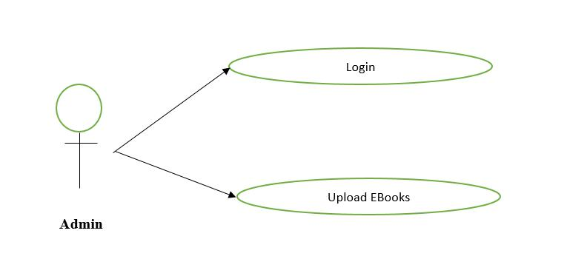

**Figure 4.1: User class diagram for admin**

### 3.7.2 Server

The server can perform multiple tasks in the user classdiagram for the server. The server extracts the text which is uploaded by the user. Once the text is extracted, the extracted file will be summarized. and then the summary will be converted to an audio clip where the user wants to listen to the audio of the summary. Finally, the entire information will be sent to the hardware input.

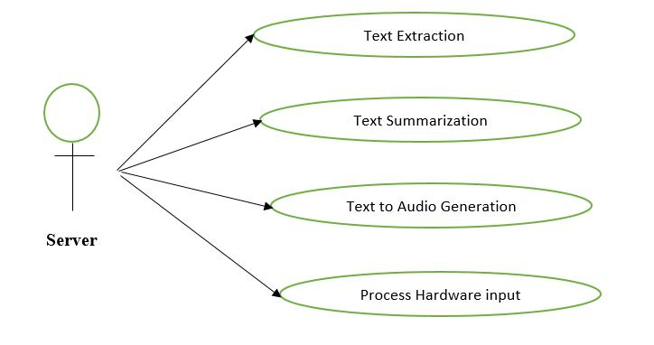

**Figure 4.: User class diagram for admin**

### 3.7.3 USER

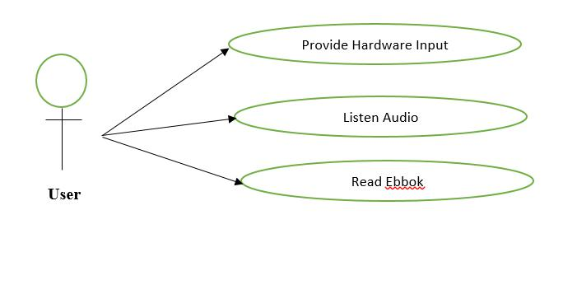

**Figure 4.3: User class diagram for user**

In the user class diagram for user, the user can provide the hardware input and once the user is provided the hardware input data. The user can listen to the audio clip of the summary. And if the user wants to read that particular book, they can read the summary of the book along with the audio clip.

## 3.7.4 Use class diagram

Login

View user Details

Upload VR Books

Manage VR Library

Register

Select VR Books

Read VR Books

Admin

User

Logout

**Figure 4.4: Use Case diagram**

A use case diagram is a representation of a user's interaction with a system that shows the relationship between the user and the many use cases in which the user is involved at its most basic level. Admin offers a variety of use cases, as illustrated in this use case diagram, including login, display user information, control vrlibrary, and logout.Login, register, selectbook, and registering in VR are some of the use cases available to the user.

### 3.8 Hardware Requirements

The initial development was done on a laptop with the following specifications:

|  |  |
| --- | --- |
| Processor | Intel Core i5 processor |
| CPU | 8250U CPU @ 1.60GHz |
| RAM | 8GB |
| System type | 64bit Operating System, x64-based processor |
| Hard Disk | 1 TB |
| Arduino nano  MPU 6050  Android Phone  Power supply |  |

**Table 3.1 : Hardware requirements**

**3.9 Software requirements**

The software requirements of the project are tabulated below.

|  |  |
| --- | --- |
| Operating System | Windows 7 / 8 or above. |
| Language | Python, html, Java |
| Tool | Python IDE, NetBeans IDE, unreal engine |
| Technologies | VR, web development,text summarization |

#### Table 3.2 :Software Requirement

**CHAPTER-4**

**PROPOSED METHODOLOGY**

## 4.1 System Architecture :

The overall system architecture is illustrated in Figure 4.1

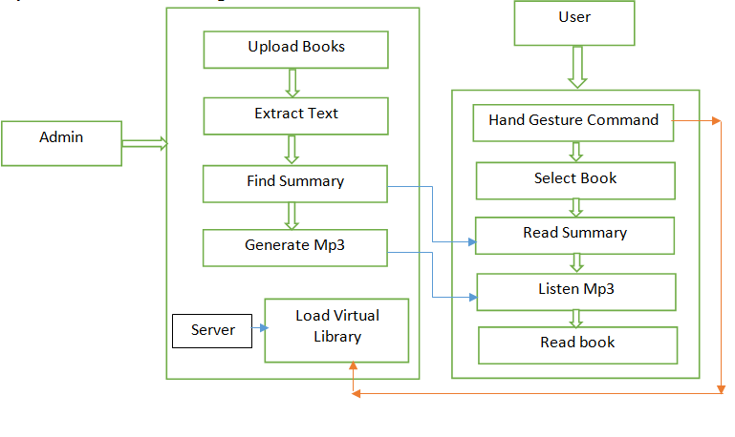

**Fig 4.1 System Architecture**

The method of architectural configuration is concerned with the design of a fundamental basic structure for a framework. It requires understanding the individual components of the system and the relationships between these segments. Admins can login and upload ebooks. The admin will be in charge of logging in users and uploading ebooks; once the user has finished uploading books, the user can log out.The server can do multipletask. The server extracts the text which is uploaded by the user. Once the text is extracted, the extracted file will be summarized. and then the summary will be converted to an audio clip where users can listen to the audio of the summary. Finally, the entire information will be sent to the hardware input. The user can provide the hardware input and once the user is provided the hardware input data. The user can listen to the audio clip of the summary.

**4.2 System Design :**

### 4.2.1 Data flow model-Level -0

There are three components: User, Admin, and vrlibrary. The vr library is linked to all of the components.The admin will upload book details. Once the book is uploaded, in vr head set, the user can read the uploaded book. which is shown in the following fig 5.1.

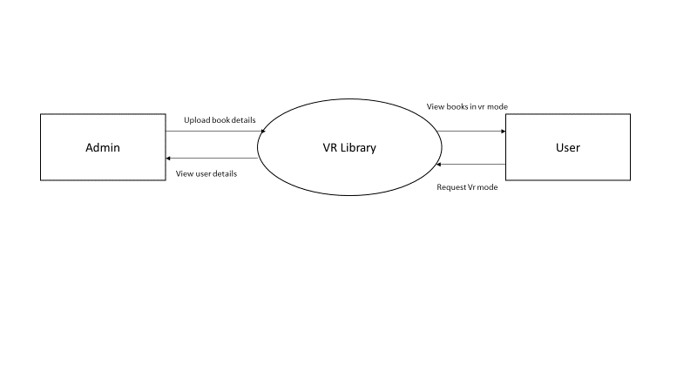

**Figure 4.2: Data flow model-Level -0**

### 4.2.2 Data flow model-Level -1

The web page is designed for login and for uploading book details once the user uploads a pdf file of a text book. The admin can view the user's information, and once the upload is complete, the user can log out of the website.

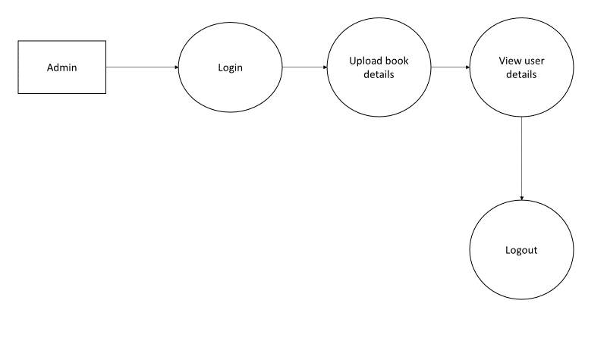

**Figure 4.3: Data flow model-Level -1**

### 4.2.3 Data flow model-Level -2

Users should login to the Web page and we will use Unreal Engine 4 for VR in the design part to create interactive environments that are believable to the human mind, VR and mixed reality, requiring complex scenes rendered at very high framerates. Basic functions like scene construction, scene roaming, and interaction need to be enforced by the system. To create the virtual library framework, the system uses the Unreal engine and the Unreal Studio. Users can choose books from a head-mounted display and read them page by page, as well as listen to audio clips of summary.

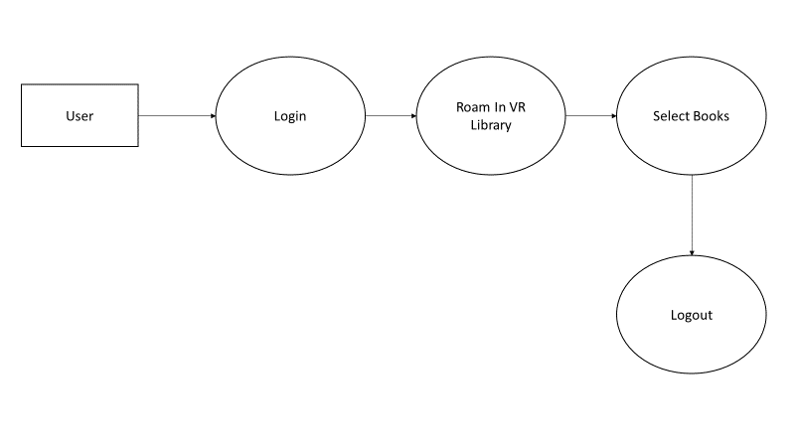

**Figure 4.4: Data flow model-Level -2**

## 4.3 Sequence Diagram

System admin can collect the e-books of all available library books and link those books to the VR system where students will use the VR headset to access those e-books. The system administrator will then update the library resources and manage them as required by the VR system. The book and model data of the virtual digital library system is stored on the server side. When required, the server interacts with the database to query, add or remove the data. The database includes information about the user. Admins can login and upload ebooks. The admin will be in charge of logging in users and uploading ebooks; once the user has finished uploading books, the user can log out.The server can do multipletask. The server extracts the text which is uploaded by the user.Once the text is extracted, the extracted file will be summarized. and then the summary will be converted to an audio clip where users can listen to the audio of the summary. Finally, the entire information will be sent to the hardware input. The user can provide the hardware input and once the user is provided the hardware input data. The user can listen to the audio clip of the summary.

**Figure 4.5 Sequence Diagram**

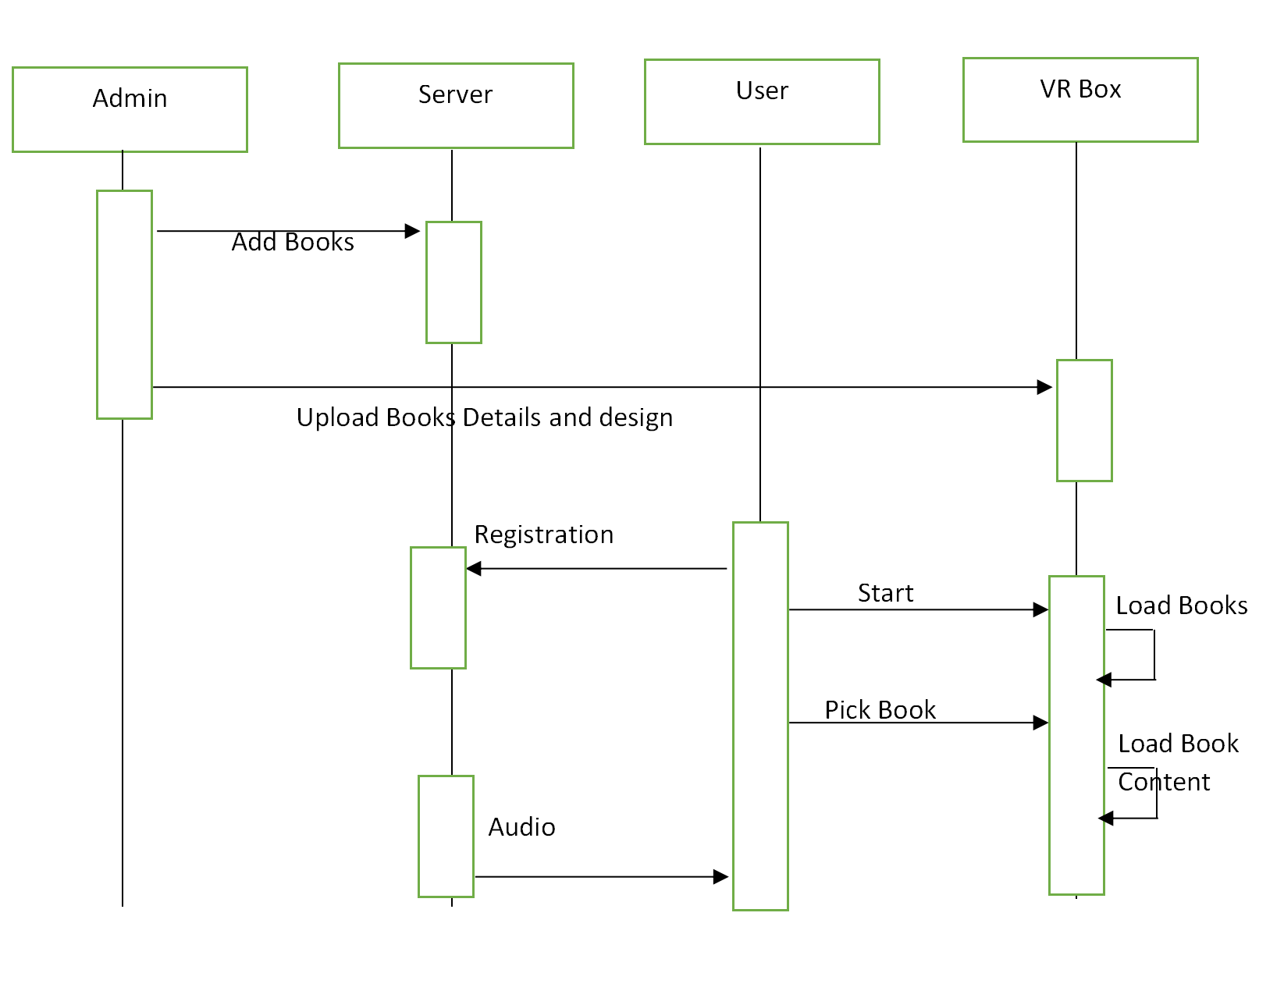

**4.4 Proposed Methodology**

**4.4.1 Add E-Books:**

System admin will collect the e books of all the library books available and add those books to the VR System where students can be able to access those e-books through a VR headset. System admin will then update and maintain the library resources as required by the VR System. The server side stores the book and model data of the virtual digital library system. At the same time, the core system of virtual library is running on the server side, and responds to the requests of the user from the client. The server communicates with the database when necessary to query, add or delete the data. The database contains book information, user information, and others. A web application has been designed for the admin, who can upload ebooks in pdf format. The pdf file is processed by the server to extract the text content from it. The complete text is processed for text summarization. Users can listen and read the summary before reading the ebook.

**4.4.2 Text extraction Method:**

We used apache pdfbox to extract the text from the pdf format. Apache PDFBox is a Java library that makes creating and converting PDF documents easier. You can use this library to build, convert, and manipulate PDF documents in Java programs. In addition, PDFBox provides a command-line tool that can be used to perform different operations on PDF files using the available Jar file.

**4.4.3 Text summarization Methods :**

**Gensim Summarizer:** In the Gensim summarization module, TextRank, an unsupervised algorithm based on weighted summarization is implemented. It is based on the well-known PageRank algorithm.

The PageRank algorithm generates a probability distribution that is used to reflect the likelihood that an individual clicking on random links would end up on a specific page. PageRank can be measured for any size range of documents. Several research papers presume that at the start of the statistical process, the distribution is uniformly distributed among all documents in the set.

The PageRank computations necessitate multiple passes through the array, referred to as "iterations," in order to get approximate PageRank values to fit the theoretical true value more closely.A probability is a number between 0 and 1 that represents the likelihood of anything happening. A "50 percent chance" of anything occurring is generally expressed as a 0.5 probability.

**Text Rank:** TextRank is based on the Google Search Engine's page Rank algorithm. To put it another way, it favors pages with a higher number of visitors. The ties between pages are traditionally represented as a matrix, as seen in the image below. This matrix is converted to a transfer probability matrix by dividing the number of links on each page that affect the surfer's path.

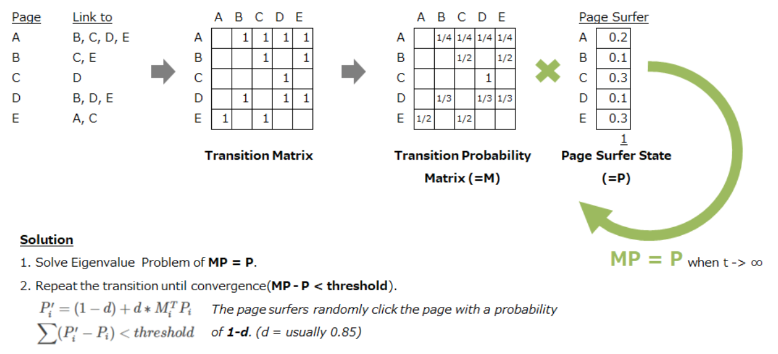

**Fig 4.6 Page Rank Working**

**LexRank in Text Summarization :**

LexRank is an unsupervised graph-based methodology that is similar to TextRank. LexRank uses IDF-modified Cosine as the similarity metric to evaluate two sentences. This similarity determines the weight of the graph edge between two sentences. LexRank also has an intelligent post-processing stage that makes sure the top sentences chosen for the description aren't too close. LexRank is another graph-based method for summarization. It is similar to TextRank and unsupervised in nature. LexRank uses Cosine similarity instead of Jaccard between two sentences. This similarity score will be used to build a weighted graph for all the sentences in the document. LexRank also ensures that the top most sentences are not too similar to one another.

**Latent Semantic Analysis (LSA) in Text Summarization:**

LSA preserves as much information as possible by projecting data into a lower-dimensional vacuum. Singular vectors may be used to capture and describe patterns of repeated word combinations in a corpus.according to one interpretation of this spatial decomposition operation. The singular value's magnitude indicates the pattern's significance in a text.

### Occurrence matrix:

LSA may use a document-term matrix to describe the occurrences of terms in documents. It's a sparse matrix with rows corresponding to words and columns corresponding to documents. A typical example of matrix element weighting is the tf-idf (term frequency–inverse document frequency) weighting scheme.A matrix element's weight is proportional to how many times the words appear in each document, with uncommon terms receiving a higher weight to represent their relative importance.

**Rank reduction:**

After the construction of the occurrence matrix, LSA finds a low-rank approximation to the term-document matrix. There could be various reasons for these approximations:

* The original term-document matrix is presumed too large for the computing resources; in this case, the approximated low rank matrix is interpreted as an approximation (a "least and necessary evil").
* The original term-document matrix is presumed noisy: for example, anecdotal instances of terms are to be eliminated. From this point of view, the approximated matrix is interpreted as a de-noisified matrix (a better matrix than the original).
* The original term-document matrix is presumed to be overly sparse relative to the "true" term-document matrix. That is, the original matrix lists only the words in each document, whereas we might be interested in all words related to each document-generally a much larger set due to synonymy.

As a result of the rank reduction, several measurements have been merged and are dependent on multiple terms:

(car), (truck), and (flower) are all words that can be used to describe a vehicle, a truck, or a flower —- (flower) = (1.3452 * car + 0.2828 * truck),

The problem of identifying synonymy is alleviated since the rank lowering is meant to combine the dimensions associated with terms that have similar definitions. It also aids in the reduction of polysemy by combining the components of polysemous terms pointing in the "real" direction with the components of words with the same meaning.On the other hand, components pointed in different directions appear to even out or, at worst, be smaller than those pointing in the intended sense directions.

**Luhn’s Summarization in Text Summarization:**

Luhn’s algorithm is based on the fact that humans are creatures of habit and will repeat keywords throughout a document. More importantly, he believes that the keywords an author uses are well defined and represent a single concept or notion. Even if an author tries to use reasonable synonyms for his or her keyword, they will eventually run out and fall back to using the best word that defines the notion, which will be the keyword that is repeated the most. Running with the notion that an author will be repetitive by using a limited number of keywords to convey meaning, we can begin to rank sentences based on keyword frequency and proximity within a sentence. To determine sentence weight, we first look for significant words in a sentence, then take a subset of words in the sentence with the first and last word in the subset being a significant word. A subset is closed when four or five insignificant words are present before the next use of a significant word. Within the subset, we now count the number of times the significant word is present, then divide by the number of total words in the subset. This number will be the weight given to that sentence.

If a given sentence is long enough to contain multiple subsets of significant words, we simply take the higher subset score as the weight of the sentence. To generate the auto-extraction, we only need to take the highest x sentences where x is a user defined number of sentences for summary length and put the sentences back in the order they first appear. Besides just taking the highest rated sentences, it is also possible to break the text down into paragraphs and take the highest y sentences of each paragraph where y is x divided by the number of paragraphs.

**4.4.5 Design VR Library:**

The next phase is to design the interior of the library. Where we will make a digital representation of the physical library premise. In the design part, we will use Unreal Engine 4 for VR to create immersive experiences that are believable to the human mind. VR and mixed reality require complex scenes rendered at very high framerates. The system needs to implement basic functions such as scene building, scene roaming, and scene interaction.The system uses the Unreal engine to develop the virtual library system and uses the Unreal Studio software to model virtual buildings and other objects.

**4.4.6 Hardware Observation:**

To virtually roam and interact inside the library, we will use a gesture control mechanism. The movement of the person using the VR headset will be assisted with the help of Aurduino and node mcu by hardware Serial communication. Nodemcu can receive data using RX (nodemcu) and TX (Arduino). The data is sent from Arduino to NodeMCU. NodeMCU requests the data from the Arduino by sending a character. When the Arduino detects incoming data, it sends the data in serial as a response.

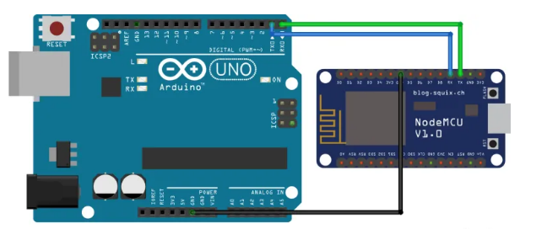

**Fig 4.7 Aurduino and Node Mcu Guesture**

**4.4.7 NodeMCU to Server connection:**

We are using the Socket program. Socket communication is a way of connecting two nodes on a network to communicate with each other. One socket (node) listens to a particular port at an IP, while the other socket reaches out to the other to form a connection. The Server forms the listener socket while the client reaches out to the server. We can set SSID and Password for AP mode which will be used to authenticate other devices while connecting to it. NodeMCU provides network APIs to use it as a TCP server.

**4.4.8 Select Books:**

The next part is to select e-books from the virtual library. The user must have a head mounted display for the virtual sense of the VR Library. In the VR Library, all books will be in the form of digital books, but they will appear to us as if real books are stacked together in the self of our real physical library.To access the books in the VR Library, we will point to the book using a pointer device and click on it. In virtual reality, when a user walks near to a book, when we click the respective book, it will open like a real physical book in VR Scene. Users can go through the book by page by page and can also see the entire summary of the book and can listen to the audio clip of the summary.

**CHAPTER-5**

**IMPLEMENTATION DETAILS AND PSEUDOCODE**

This chapter describes the details of the implementation of the VR Library System. The first phase involves the implementation of the Adding Ebooks and Text Summarization Methods Used. A web application has been designed for the admin, who can upload ebooks in pdf format and the next phase is Designing of VRLibarary. Here the section 5.1 describes the software tools used in the implementation and section 5.2 gives a brief overview of the modules implemented.

## Software tools

The project was initially developed on a Laptop with Intel(R) Core (TM) i5-8250U CPU @ 1.60GHz, 1801 MHz .The project has been developed using the programming language python 3.7 with the help of the following libraries and packages as shown in table 5.1.

#### Table 5.1: Software Tools

|  |  |  |
| --- | --- | --- |
| **Task** | **Softwars/Library** | **Function** |
| Pdf Text Extraction | apache pdfbox. | 2.0.22 |
| Natural Language Processing | NLTK | 3.3.0 |
| Machine learning models | Sumy | 0.20.1 |
| Data Array Processing | NumPy | 1.16.5 |
| Data structure and analysis tool | Panda | 0.25.1 |
| Epic Games | Unreal Engine | 4 |
| Arduino and node mcu | Aurdino | 1.8.1.4 |

**5.2 Modules**

We have four modules: adding books, text summarization, virtual reality design, and selecting books.We proposed a virtual reality system in which the user will have an immersive experience of exercising in a 3D world. Instance reading of ebooks can be done with the help of an android smart phone. This will enable superimposing the real and virtual world images, there by giving an entirely new viewing experience. A web application has been designed for the admin, who can upload ebooks in pdf format. The pdf file is processed by the server to extract the text content from it. The complete text is processed for text summarization. Users can listen and read the summary before reading the ebook. We can feel like moving around the virtual library and pick up book to read.

**CHAPTER-6**

**RESULTS AND DISCUSSION**

This chapter presents the results obtained by the implementation of the system as described in the previous sections. The results presented here are further discussed to help understand the importance of the techniques used in implementation of this project.

## 6.1 Web Page of VR Library

##### A web application has been designed for the admin, who can upload ebooks in pdf format. The pdf file is processed by the server to extract the text content from it**.** Figure 6.1 depicts the home page of the vr library, where administrators can upload ebooks by logging in and then logging out once the ebook has been uploaded.

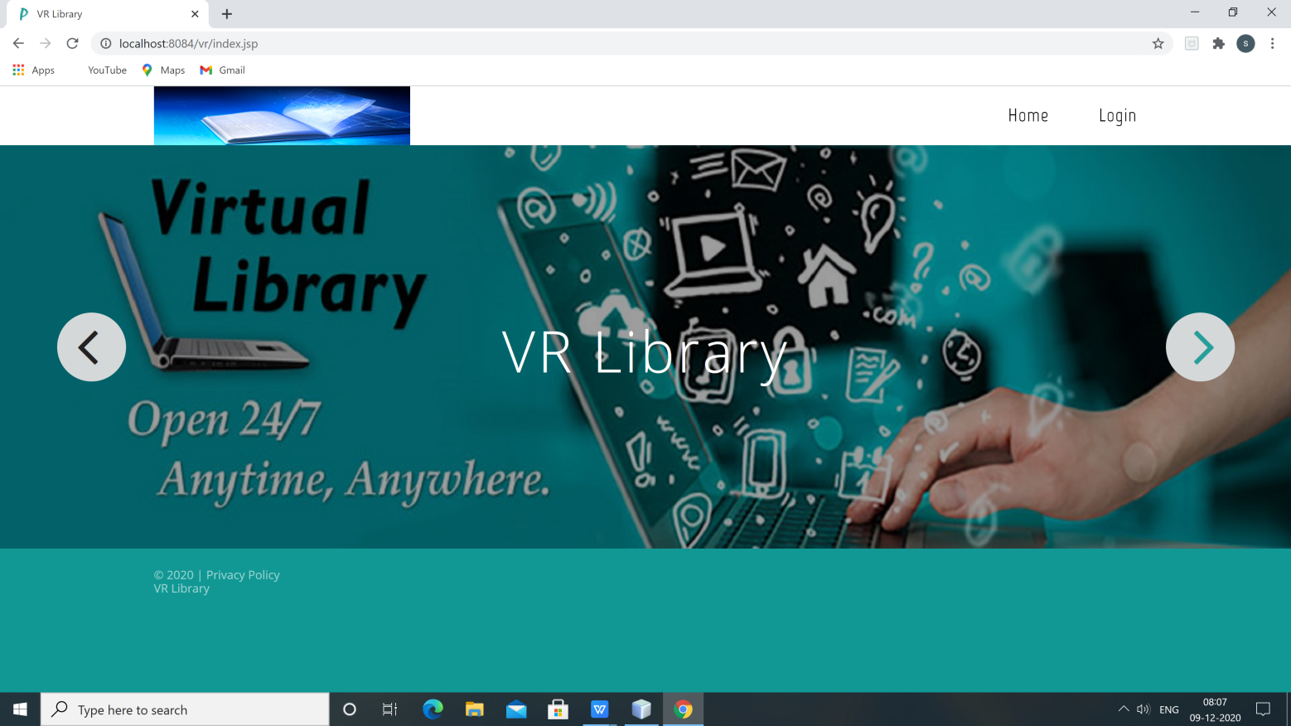

#### Figure 6.1: web page for vr library screenshot

30

## 6.2 Upload E-book

The Admin will upload the Ebook with Book ID, Book Name, Author of Book and File Name of the pdf. Once the Pdf file is uploaded by entering all the details, so that user can access the ebook. The same screenshot is shown in fig 6.2.

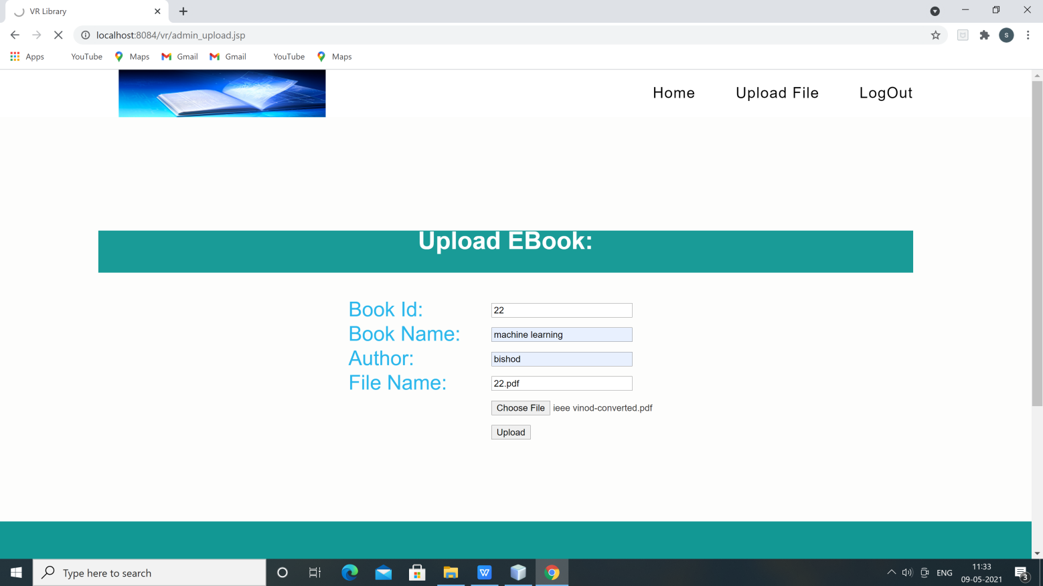

#### Figure 6.2: upload E-book page for vr library screenshot

31

## 6.3 Text Extraction from Pdf File

Once the pdf file is uploaded by admin, the uploaded pdf file will be saved on the server. The entire pdf file text will be extracted, which can be shown in figure 6.3.

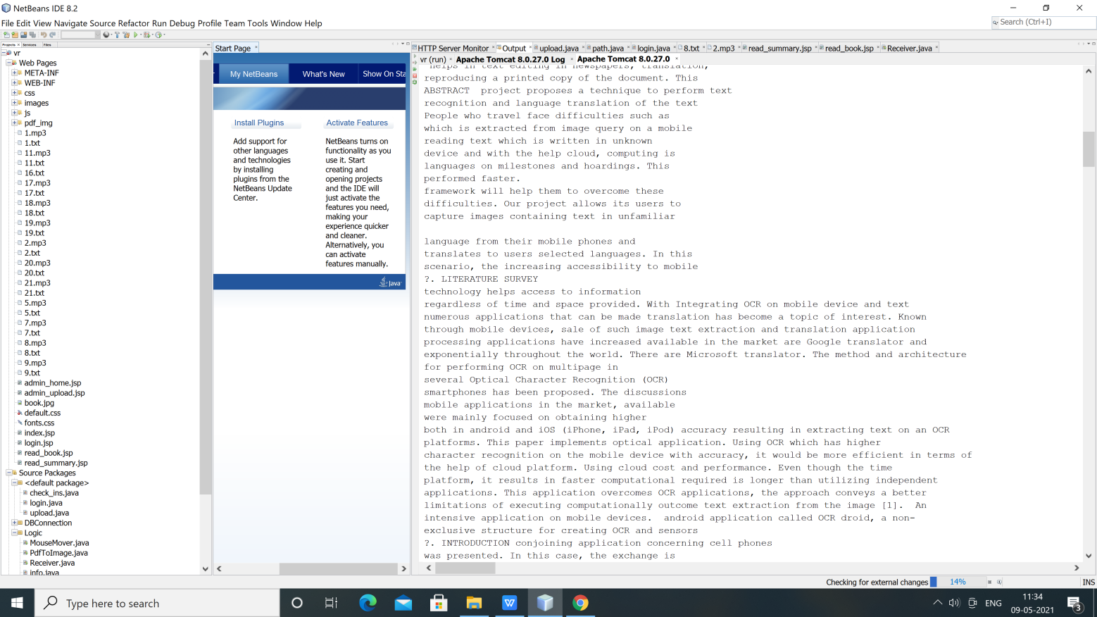

#### Figure 6.3: Text Extraction from pdf file screenshot

32

**6.4 Text Summary of Pdf file**

# The Text Extarction file will be saved on the server. The Extracted File will be Summarized  By using the Gensim Summarizer method, the entire pdf file will be summarized, and we can see the summary lines from the pdf which is shown in fig 6.4.

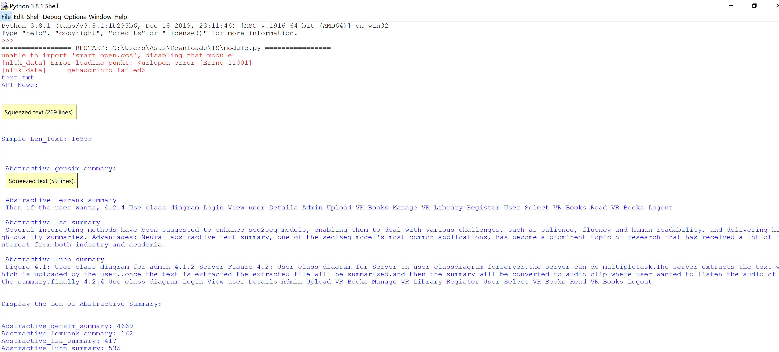

#### Figure 6.4: Text summary from pdf file screenshot

33

**6.5 VR Design of Library**

The interior design of the library. Where we will make a digital representation of the physical library premise. In the design part, we will use Unreal Engine 4 for VR to create immersive experiences that are believable to the human mind. VR and mixed reality require complex scenes rendered at very high framerates. The system is implemented by basic functions such as scene building, scene roaming, and scene interaction. The system uses the Unreal engine to develop the virtual library system and uses the Unreal Studio software to model virtual buildings and other objects. To select e-books from the virtual library, the user must have a head mounted display for the virtual sense of the VR Library. In the VR Library, all books will be in the form of digital books, but they will appear to us as if real books are stacked together in the self of our real physical library.To access the books in the VR Library, we will point to the book using a pointer device and click on it. In virtual reality, when a user walks near to a book, when we click the respective book, it will open like a real physical book in VR Scene, so the entire VR design of the library is shown in fig 6.5.

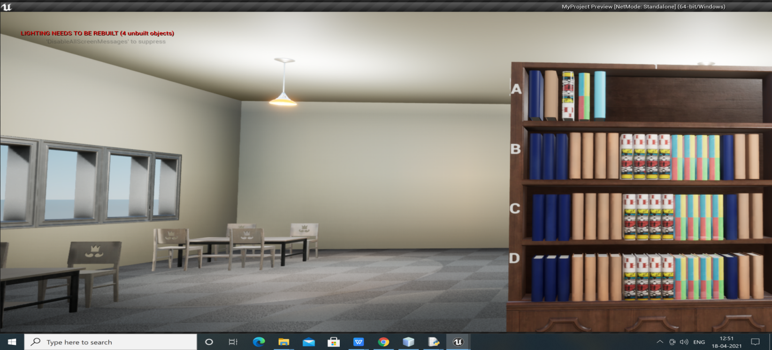

#### Figure 6.5: Design of VR Library screenshot

34

**6.6 Text Summary And Audio file Display in VR**

When we click the respective book, it would open like a real physical book in VR Scene. Users can go through the book by page by page and can also see the entire summary of the book and can listen to the audio clip of the summary. To go through the pages we will use the next or previous button of the hand device, which is shown in fig 6.6.

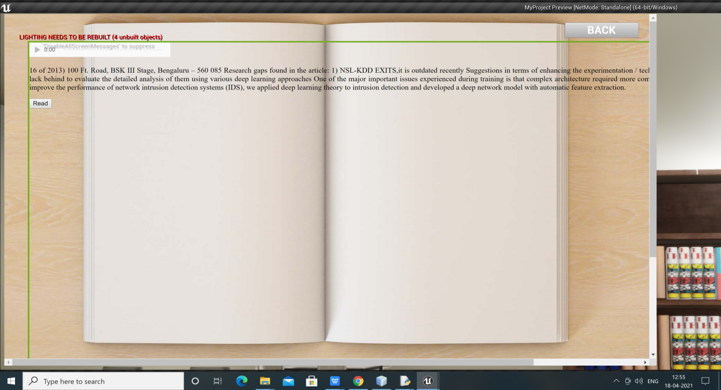

#### Figure 6.6: Text Summary and audio file Display screenshot

35

# CHAPTER-7

**CONCLUSION AND FUTURE WORK**

The fundamental motivation for developing this product was to create specialised VR hardware and software that could be utilised anywhere. The processor and monitor on the phone, as well as the hardware found in personal computers, are utilised by available devices. The future version of the programme will resolve the aliasing problem. A improved display will be included in the system.The device's case design will be optimised as well. The proposed virtual reality can provide an overview of the ebook and even allow users to listen to it.

# CHAPTER-8

# References

[1]Qin, JinfengLei, The Application of Virtual Reality Technology in Advertising Communication , 2019.

[2] Kai Zhang, Sai-Jun Liu, The Application of Virtual Reality Technology in Physical

Education Teaching and Training, 2016.

[3] Panagiotis Kouris, Georgios Alexandridis, Andreas Stafylopatis,Abstractive text summarization

based on deep learning and semantic content generalization , 2019.

[4] Neural Abstractive Text Summarization with Sequence-to-Sequence Models,tian shi, yaser

keneshloo, naren ramakrishnan, Chandan k. Reddy,2020.

[5] A Survey on Abstractive Text Summarization,N. Moratanch, Dr. S. Chitrakala,2016.

[6] K. S. Hale and K. M. Stanney, Handbook on Virtual Environments, 2nd edition, CRC Press, 2015.

[7] Steaven M. Lavelle, Virtual Reality URL: http://msl.cs.uiuc.edu/vr/, 2015.

[8] https://www.oculus.com/en-us/, 2015.

[9 ] http://www.htcvive.com/us/,2015.

[10] https://www.playstation.com/enin/explore/ps4/features/playstation-vr/,2015.

[11] https://www.visusvr.com/, 2015.

[12] William R. Bussone, Linear and Angular Head Accelerations in Daily Life,

URL: http://scholar.lib.vt.edu/theses/available/etd-08182005- 222028/unrestricted/thesis.pdf, 2005.

[13] InvenSense, “MPU-6000 and MPU-6050 Product Specification Revision 3.4”,

URL: http://store.invensense.com/datasheets/invensense/MPU6050_DataSheet_V3%204.pdf, 2013.

[14] Arduino, “Arduino Uno”, URL: https://www.arduino.cc/en/Main/ArduinoBoardUno, 2015.

[15] Riedl, M.O.. Human- centered artificial intelligence and machine learning. Human Behavior and Emerging Technologies ,2019.

[16] Ciechanowski, L., Przegalinska, A., Magnuski, M. and Gloor, P, In the shades of the uncanny valley: An experimental study of human– chatbot interaction. Future Generation Computer Systems, 2019.

[17] Zipp, S.A. and Craig, S.D, The impact of a user’s biases on interactions with virtual humans and learning during virtual emergency management training. Educational Technology Research and Development, 2019.

[18] Wang, Y., Li, J. and Wang, H.H,Cluster and cloud computing framework for scientific metrology in flow control. Cluster Computing, 2019.

[19] Fulmer, W., Mahmood, T., Li, Z., Zhang, S., Huang, J. and Lu, A., 2019, March. ImWeb: cross-platform immersive web browsing for online 3D neuron database exploration. In Proceedings of the 24th International Conference on Intelligent User Interfaces ,2019.

[20] Liao, Y. and He, J., 2020, March. Racial mirroring effects on human-agent interaction in psychotherapeutic conversations. In Proceedings of the 25th International Conference on Intelligent User Interfaces ,2020.

[21] Huang, C., Lin, W., Lai, C., Li, X., Jin, Y. and Yong, Q. Coupling the post-extraction process to remove residual lignin and alter the recalcitrant structures for improving the enzymatic digestibility of acidpretreated bamboo residues. Bioresource technology, 2019.

[22] Nota, G. and Aiello, R., The interaction type approach to relationships management. Journal of Ambient Intelligence and Humanized Computing,2019.